FY 2026 CPP Projects
HPE Networking — Wired Switching Group

System Design Documentation

April 2026

Table of Contents

Project : Log Importance Scoring & Cross-Signal Correlation

Project
Log Importance Scoring & Cross-Signal Correlation

Mentor | Abhishek Labh
Members | Sharva Dhanvi V
 | Shreeraksha M
 | Sumukha Rao H
 | Ujwal Hegde
 | Vishon Dsouza

Overview
The project builds an end-to-end offline log analysis pipeline for network infrastructure. Logs from switches, routers, syslog, and application servers are ingested via Fluent Bit, parsed and normalized using Python/Drain-style algorithms, then segmented into sessions using time-gap heuristics.
From there, features are extracted and fed into an Isolation Forest ML model alongside z-score statistical detection to flag anomalies. A NetworkX graph engine correlates log sequences to trace relationships, and a hybrid scoring engine combines all signals into a per-log importance score. Related logs are then clustered (DBSCAN) and ranked by graph centrality to surface root cause candidates.
Results are stored in PostgreSQL and Elasticsearch, and visualized through Grafana and Kibana dashboards. The ML model is kept current via a sliding window retraining strategy with periodic sampling to bound compute costs.
The core design philosophy is hybrid - combining ML, statistical, and rule-based signals for both accuracy and interpretability - with graph-based correlation enabling causal reasoning that pure anomaly detection cannot provide.

- High Level Architecture

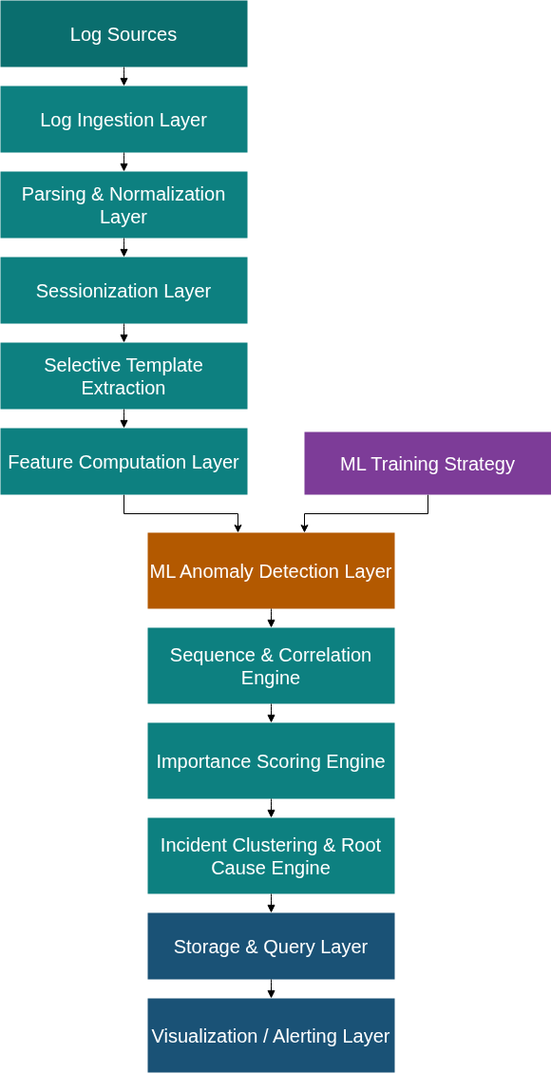
- Log Sources

Log Origins | • Network switches / routers  • Linux syslog  • Application servers  • Web services  • Security tools
Supported Formats | • Plain text  • Syslog  • JSON  • Key-value
Arrival Mechanisms | • File tailing  • Streaming agents  • Message queues

- Log Ingestion Layer

Responsibilities | • Load batch log datasets  • Preserve ordering  • Assign sequence numbers
Technologies | • Fluent Bit  • File readers / batch loaders
Technology Justification | • Fluent Bit provides efficient log collection and supports multiple formats with minimal overhead.  • Batch ingestion is sufficient since the system is offline, reducing system complexity compared to real-time streaming.

- Parsing and Normalization Layer

Responsibilities | • Convert logs to structured schema  • Extract metadata  • Tokenize messages
Technologies | • Python (regex, parsing libraries)  • Log parsing frameworks (e.g., Drain-style parsing)
Technology Justification | • Python provides strong text-processing capabilities and flexibility for heterogeneous log formats.  • Structured normalization is essential for downstream ML models which require consistent feature inputs.

- Sessionization Layer

Responsibilities | • Segment logs into sessions using time-gap heuristics
Technologies | • Custom logic (Python / Pandas)
Technology Justification | • Time-based segmentation is computationally inexpensive and effective for offline datasets.  • Enables context-aware analysis without requiring complex stateful systems.

- Selective Template Extraction

Responsibilities | • Group high-frequency logs into templates
Technologies | • Drain / LogSig (lightweight log parsing algorithms)
Technology Justification | • These algorithms efficiently extract templates without heavy computation.  • Selective application avoids unnecessary overhead and improves scalability.

- Feature Computation Layer

Responsibilities | • Generate statistical, structural, and temporal features
Technologies | • Python (NumPy, Pandas)  • Feature pipelines
Technology Justification | • NumPy and Pandas enable efficient batch computation over large datasets.  • Structured feature engineering is essential for effective anomaly detection.

- ML Anomaly Detection Layer

Model | • Isolation Forest
Technologies | • Scikit-learn  • Statistical anomaly detection (z-score)
Technology Justification | • Isolation Forest is well-suited for unsupervised anomaly detection in tabular data.  • Scikit-learn provides a robust and optimized implementation with minimal setup.  • Does not require labeled data, making it ideal for log analysis.

- Sequence and Correlation Engine

Responsibilities | • Build graph of log relationships
Technologies | • NetworkX
Technology Justification | • NetworkX allows flexible graph construction and analysis.  • Supports centrality, connectivity, and path analysis needed for root cause detection.  • Suitable for offline batch graph processing.

- Importance Scoring Engine

Responsibilities | • Combine multiple signals into a final importance score
Technologies | • Python (custom scoring logic)
Technology Justification | • Custom scoring provides interpretability and tunability.  • Hybrid scoring allows combining ML outputs with domain knowledge.

- Incident Clustering & Root Cause Engine

Responsibilities | • Cluster related logs  • Identify root cause candidates
Technologies | • Clustering algorithms (DBSCAN / hierarchical clustering)  • Graph analytics (centrality measures)
Technology Justification | • DBSCAN handles arbitrary cluster shapes and noise effectively.  • Graph centrality helps identify influential / root cause nodes.  • Suitable for unsupervised incident grouping.

- Storage Layer

Stores | • Logs  • Features  • Scores  • Incidents
Technologies | • PostgreSQL  • Elasticsearch
Technology Justification | • PostgreSQL ensures strong consistency and structured storage.  • Elasticsearch enables fast full-text search and log exploration.  • Combination supports both analytical queries and search use cases.

- Visualization and Alerting Layer

Displays | • Anomalies  • Incidents  • Timelines
Technologies | • Grafana  • Kibana
Technology Justification | • Grafana excels at time-series visualization and monitoring.  • Kibana integrates well with Elasticsearch for log exploration.  • Together provide comprehensive observability.

